**ASSIGNMENT-3**

Subject – Computer Science Workshop-1(CSE 2141)

NAME – DEEPTESH ROUT

Registration Number – 2341018166

Section – 23412G1 Branch – B. Tech (CSE)

1. Create a webpage using jQuery that contains three buttons to change the background

colour of the entire page to red, blue, or green, depending on which button is clicked.

Additionally, add a separate button that toggles the visibility of all <div> elements on

the page. When the toggle button is clicked, the <div> elements should either be shown

or hidden based on their current visibility state. Ensure that the background color

change and visibility toggle functionalities work smoothly together.

HTML CODE :-

<!DOCTYPE html>

<head>

  <title> Deepteshrout Assignment 3 Question1 </title>

  <script src=" https://ajax.googleapis.com/ajax/libs/jquery/3.3.1/jquery.min.js "></script>

</head>

<body>

  <button id="redButton">Red</button>

  <button id="blueButton">Blue</button>

  <button id="greenButton">Green</button>

  <button id="toggleDivs">Toggle Div Visibility</button>

  <div>This is a sample content inside a <code>div</code> element.</div>

  <div>Here's another <code>div</code> element with some text.</div>

  <script>

    $(document).ready(function() {

      $('#redButton').click(function() {

        $('body').css('background-color', 'red');

      });

      $('#blueButton').click(function() {

        $('body').css('background-color', 'blue');

      });

      $('#greenButton').click(function() {

        $('body').css('background-color', 'green');

      });

      $('#toggleDivs').click(function() {

        $('div').toggle();

      });

    });

  </script>

</body>

</html>

NORMAL OUTPUT

OUTPUT 1 (RED BACKGROUND) OUTPUT 2 (BLUE BACKGROUND)





OUTPUT 3 (GREEN BACKGROUND) TOGGLE VISIBLITY

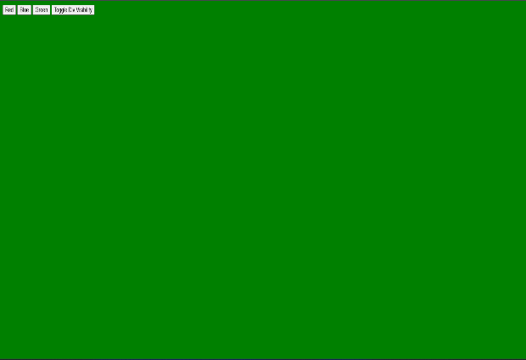

2. Write a jQuery program to perform the following actions on a <div> element: when the

user clicks on the <div>, its text should change to 'Clicked!'; when the user double-

clicks, the background color should change to orange; when the user hovers (mouse

enters) over the <div>, the border color should change to green; and when the user

moves the mouse away (mouse leaves), the border color should revert to black. The

<div> should initially have a light blue background, a black border, and centered text.

HTML CODE:-

<!DOCTYPE html>

<head>

    <title> Deepteshrout Assignment 3 Question2 </title>

    <script src=" https://ajax.googleapis.com/ajax/libs/jquery/3.3.1/jquery.min.js "></script>

    <script>

        $(document).ready(function() {

            $("#myDiv").click(function() {

                $(this).text("The text has been changed!");

            });

            $("#myDiv").dblclick(function() {

                $(this).css("background-color", "green");

            });

            $("#myDiv").hover(

                function() {

                    $(this).css("border", "5px solid green");

                },

                function() {

                    $(this).css("border", "none");

                }

            );

        });

    </script>

</head>

<body>

<div id="myDiv" style="padding: 20px; background-color: lightblue; cursor: pointer;">

    Click me to change my text!

</div>

</body>

</html>

OUTPUT 1

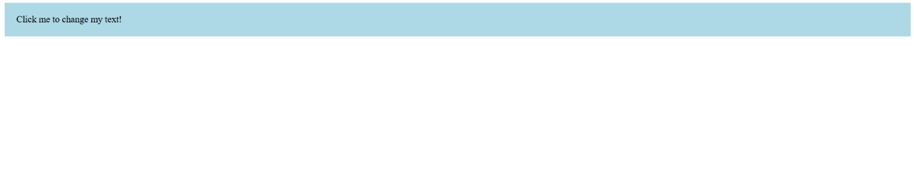

OUTPUT 2

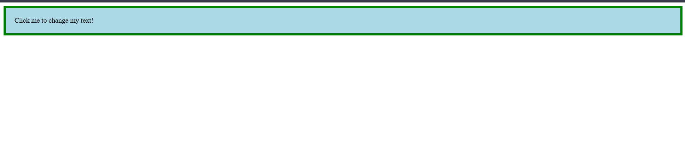

OUTPUT 3

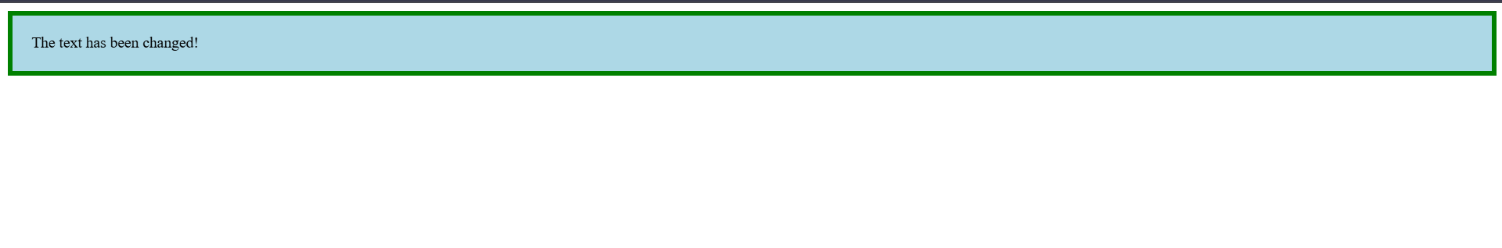

3. Write a jQuery program that starts an animation on a <div> element when a 'Start'

button is clicked and stops the animation when a 'Stop' button is clicked. The animation

should increase the width of the <div> from 100px to 400px over 2 seconds. If the

'Stop' button is clicked during the animation, the <div> should immediately stop

resizing at its current width.

HTML CODE :-

<!DOCTYPE html>

<html>

<head>

    <title> Deepteshrout Assignment 3 Question3 </title>

    <script src="https://ajax.googleapis.com/ajax/libs/jquery/3.3.1/jquery.min.js"></script>

    <script>

        $(document).ready(function() {

            $("#start").click(function() {

                $("div").animate({

                     width: "400px"

                }, 3000)

            });

            $("#stop").click(function() {

                $("div").stop();

            });

        });

    </script>

    <style>

        div {

            background: dodgerblue;

            height: 50px;

            width: 100px;

            position: fixed;

        }

    </style>

</head>

<body>

    <button id="start">Start</button>

    <button id="stop">Stop</button>

    <p></p>

    <div></div>

</body>

</html>

OUTPUT 1

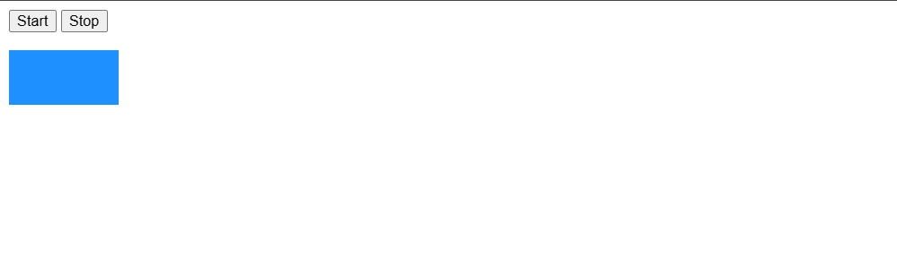

OUTPUT 2

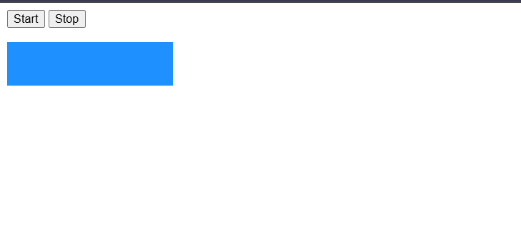

4. Write a jQuery program with two buttons: one button labelled 'Fetch Text' to retrieve

and display the text content of a <p> element using an alert, and another button labelled

'Fetch HTML' to retrieve and display the HTML content of a <div> element using an

alert.

HTML CODE:-

<!DOCTYPE html>

<head>

    <title> Deeptesh rout Assignment 3 Question4 </title>

    <script src=" https://ajax.googleapis.com/ajax/libs/jquery/3.3.1/jquery.min.js "></script>

</head>

<body>

    <p id="text-paragraph">This is a simple paragraph with some text.</p>

    <div id="html-div">

        <p>This is a <strong>div</strong> with <em>HTML</em> content.</p>

    </div>

    <button id="fetch-text">Fetch Text</button>

    <button id="fetch-html">Fetch HTML</button>

    <script>

        $(document).ready(function(){

            $('#fetch-text').click(function(){

                let textContent = $('#text-paragraph').text();

                alert("Text Content: " + textContent);

            });

            $('#fetch-html').click(function(){

                let htmlContent = $('#html-div').html();

                alert("HTML Content: " + htmlContent);

            });

        });

    </script>

</body>

</html>

OUTPUT 1

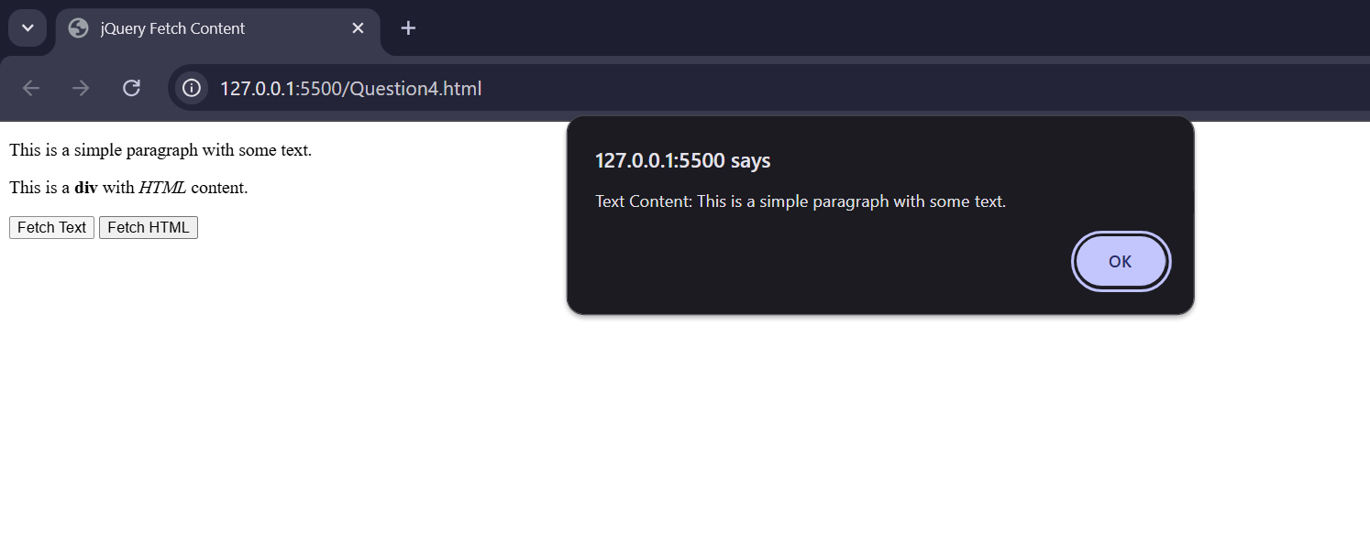

OUTPUT 2

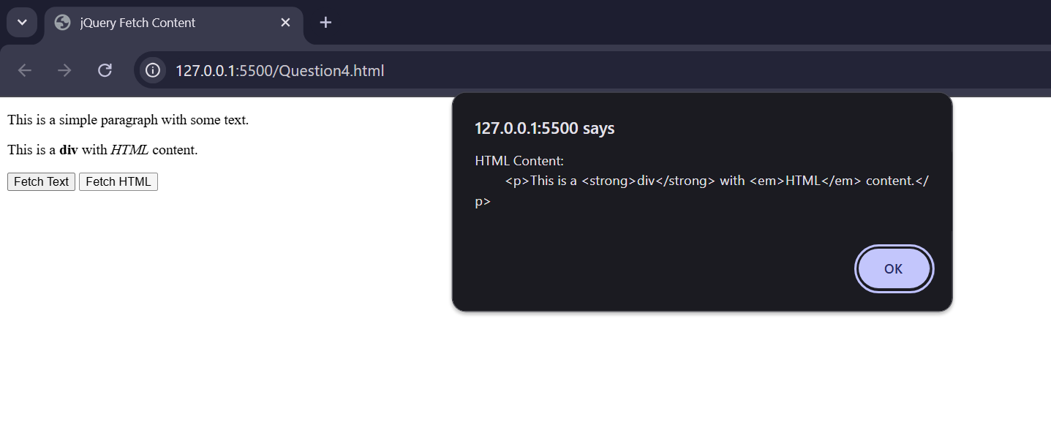

5. Write a jQuery program to manipulate an unordered list (<ul>) containing the items

'Getting Started with Full Stack,' 'HTML,' and 'CSS.' Use the append() method to add a

new list item 'CSS' at the end of the list, the prepend() method to add 'Introduction to

Full Stack Development' at the beginning, the after() method to insert a paragraph

'Topics updated' immediately after the list, and the before() method to add a heading

'List of Topics Covered' immediately before the list.

HTML CODE :-

<!DOCTYPE html>

<head>

<title>jQuery List Manipulation</title>

<script src="https://ajax.googleapis.com/ajax/libs/jquery/3.3.1/jquery.min.js"></script>

<script>

$(document).ready(function(){

$("#b1").click(function () {

$('#topic-list').append('<li>CSS</li>');

});

$("#b2").click(function () {

$('#topic-list').prepend('<li>Introduction to Full Stack Development</li>');

});

$("#b3").click(function () {

$('#topic-list').after('<p>Topics updated</p>');

});

$("#b4").click(function () {

$('#topic-list').before('<h2>List of Topics Covered</h2>');

});

});

</script>

</head>

<body>

<ul id="topic-list">

<li>Getting Started with Full Stack</li>

<li>HTML</li>

<li>CSS</li>

</ul>

<button id="b1">Append</button>

<button id="b2">Prepend</button>

<button id="b3">After</button>

<button id="b4">Before</button>

</body>

</html>

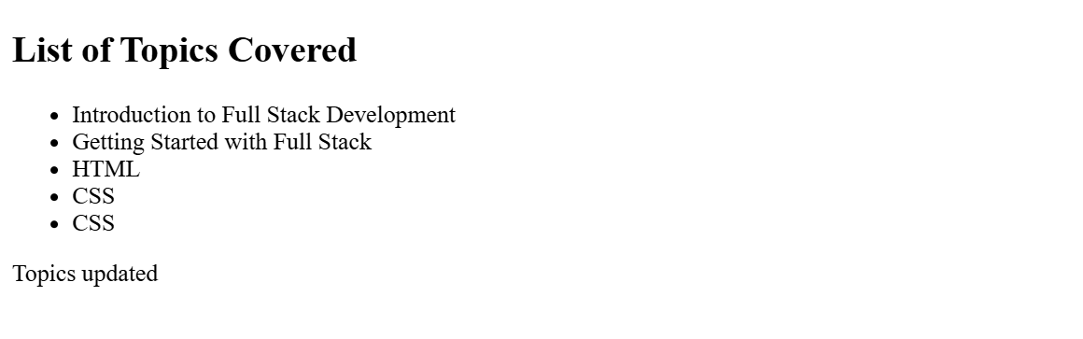 OUTPUT :-

6. Write a jQuery program that lets a user apply one of two classes ('highlight' and 'dim')

to a <div> element by clicking two different buttons. The 'highlight' class should set the

background colour of the <div> to yellow, while the 'dim' class should reduce the

opacity of the <div>. Ensure that clicking the 'Add Highlight' button applies the

'highlight' class, and clicking the 'Add Dim' button applies the 'dim' class, with the

previously applied class being removed before the new one is added.

HTML CODE :-

<!DOCTYPE html>

<head>

    <title> Deepteshrout Assignment 3 Question 6 </title>

    <script src=" https://ajax.googleapis.com/ajax/libs/jquery/3.3.1/jquery.min.js "></script>

    <style>

        .highlight {

            background-color: yellow;

        }

        .dim {

            opacity: 0.5;

        }

        #content-box {

            width: 200px;

            height: 100px;

            border: 1px solid #333;

            margin: 20px;

            padding: 10px;

            text-align: center;

            line-height: 80px;

            font-weight: bold;

        }

    </style>

</head>

<body>

    <div id="content-box">Content Box</div>

    <button id="add-highlight">Add Highlight</button>

    <button id="add-dim">Add Dim</button>

    <script>

        $(document).ready(function(){

            $('#add-highlight').click(function(){

                $('#content-box').removeClass('dim').addClass('highlight');

            });

            $('#add-dim').click(function(){

                $('#content-box').removeClass('highlight').addClass('dim');

            });

        });

    </script>

</body>

</html>

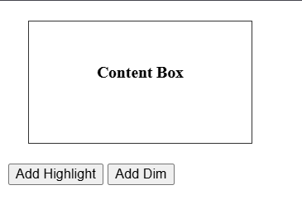NORMAL OUTPUT :-

OUTPUT 2 : - OUTPUT 3 :-

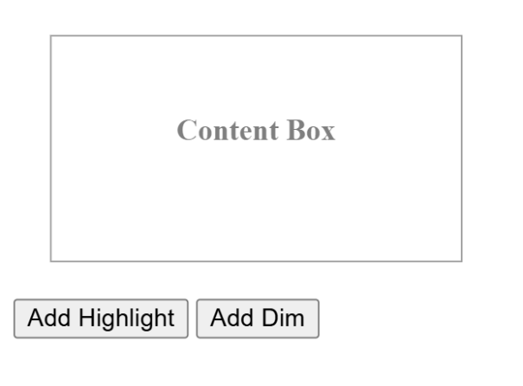

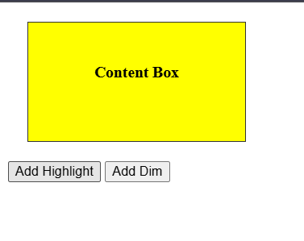

7. Create a webpage that contains a table displaying student data and an 'Add Row'

button. The 'Add Row' button should add a new row with data from input fields each

time it is clicked. Additionally, include a 'Change Colour' button to change the text colour

of all table data to red.

HTML CODE : -

<!DOCTYPE html>

<head>

<title>Deeptesh Rout Assignment 3 Question 7</title>

<style>

table {

width: 100%;

border-collapse: collapse;

}

table, th, td {

border: 1px solid black;

padding: 8px;

text-align: left;

}

th {

background-color: #f2f2f2;

}

.input-row {

margin-bottom: 15px;

}

.input-row input {

margin-right: 10px;

padding: 5px;

}

button {

padding: 7px 15px;

margin-right: 10px;

cursor: pointer;

}

</style>

<script src=" https://ajax.googleapis.com/ajax/libs/jquery/3.3.1/jquery.min.js "></script>

</head>

<body>

<h2>Student Data Table</h2>

<div class="input-row">

<input type="text" id="nameInput" placeholder="Enter Name">

<input type="text" id="ageInput" placeholder="Enter Age">

<input type="text" id="gradeInput" placeholder="Enter Grade">

<button id="addRowButton">Add Row</button>

<button id="changeColorButton">Change Color</button>

</div>

<table id="studentTable">

<thead>

<tr>

<th>Name</th>

<th>Age</th>

<th>Grade</th>

</tr>

</thead>

<tbody>

</tbody>

</table>

<script>

$(document).ready(function() {

$('#addRowButton').on('click', function() {

const name = $('#nameInput').val();

const age = $('#ageInput').val();

const grade = $('#gradeInput').val();

if (name && age && grade) {

const newRow = `<tr>

<td>${name}</td>

<td>${age}</td>

<td>${grade}</td>

</tr>`;

$('#studentTable tbody').append(newRow);

$('#nameInput').val('');

$('#ageInput').val('');

$('#gradeInput').val('');

} else {

alert('Please fill in all fields.');

}

});

$('#changeColorButton').on('click', function() {

$('#studentTable td').css('color', 'red');

});

});

</script>

</body>

</html>

OUTPUT :-

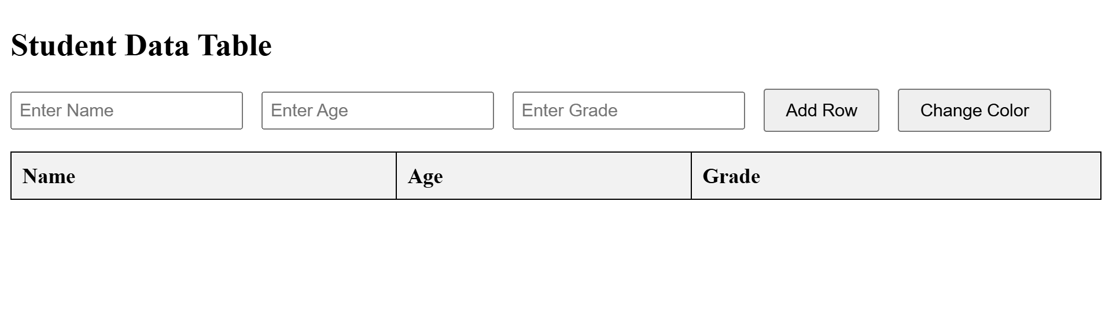

OUTPUT :-

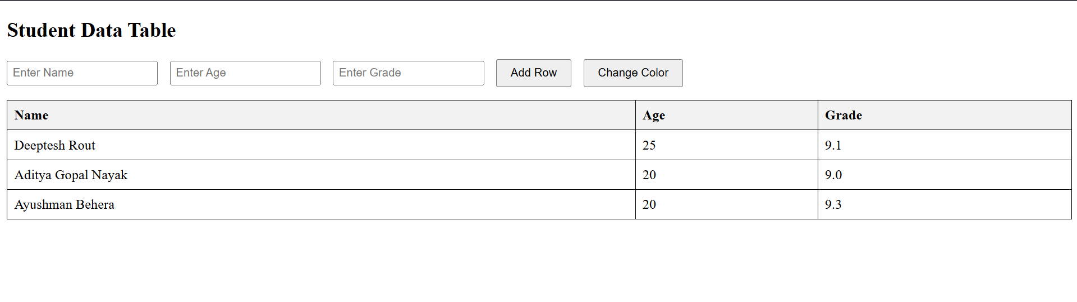

8. Create a webpage that includes a text box and a button. Write jQuery code that removes the element with an ID matching the text entered in the text box when the button is clicked. The webpage should initially contain a <div> with paragraphs, each having a unique ID.

HTML CODE:-

<!DOCTYPE html>

<head>

    <title> Deepteshrout Assignment 3 Question 8 </title>

    <script src=" https://ajax.googleapis.com/ajax/libs/jquery/3.3.1/jquery.min.js "></script>

    <style>

        body {

            font-family: Arial, sans-serif;

            margin: 20px;

        }

        #paragraphs {

            margin-bottom: 20px;

        }

        #removeInput {

            margin-right: 10px;

        }

        button {

            padding: 7px 15px;

            cursor: pointer;

        }

    </style>

</head>

<body>

    <h2>Remove Paragraph by ID</h2>

    <input type="text" id="removeInput" placeholder="Enter ID to remove">

    <button id="removeButton">Remove Element</button>

    <div id="paragraphs">

        <p id="para1">This is the first paragraph with ID 'para1'.</p>

        <p id="para2">This is the second paragraph with ID 'para2'.</p>

        <p id="para3">This is the third paragraph with ID 'para3'.</p>

        <p id="para4">This is the fourth paragraph with ID 'para4'.</p>

        <p id="para5">This is the fifth paragraph with ID 'para5'.</p>

    </div>

    <script>

        $(document).ready(function() {

            $('#removeButton').click(function() {

                var idToRemove = $('#removeInput').val();

                $('#' + idToRemove).remove();

                $('#removeInput').val('');

            });

        });

    </script>

</body>

</html>

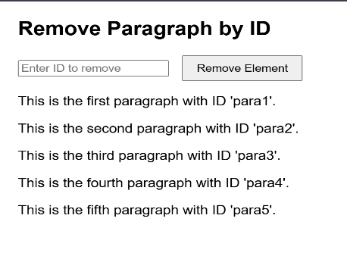OUTPUT 1:- OUTPUT 2 :-

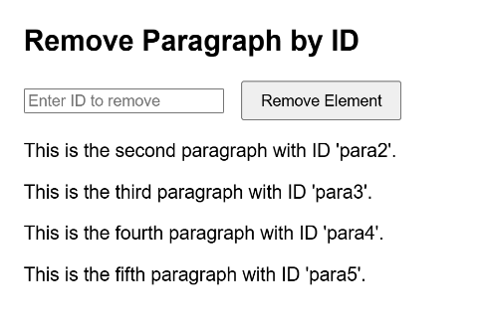

OUTPUT 3 :- OUTPUT 4:-

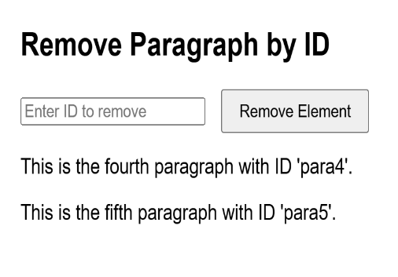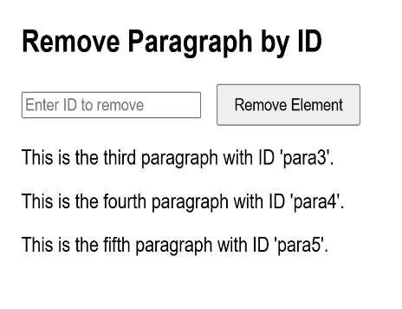

OUTPUT 5:- OUTPUT 6:-

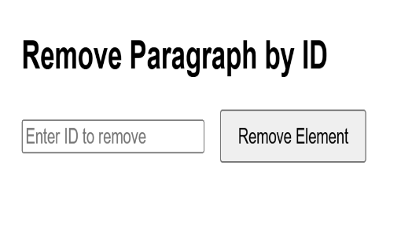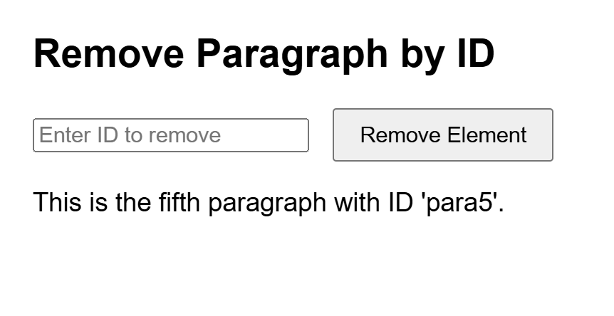

9. Write code to display a popup box without using the JavaScript alert() function.

HTML CODE : -

<!DOCTYPE html>

<head>

    <title> Deepteshrout Assignment 3 Question 9 </title>

    <script src=" https://ajax.googleapis.com/ajax/libs/jquery/3.3.1/jquery.min.js "></script>

    <style>

        #overlay {

            position: fixed;

            top: 0;

            left: 0;

            width: 100%;

            height: 100%;

            background: rgba(0, 0, 0, 0.5);

            display: none;

            align-items: centre;

            justify-content: center;

        }

        #popup-box {

            background-color: white;

            width: 300px;

            padding: 20px;

            border-radius: 5px;

            box-shadow: 0 4px 8px rgba(0, 0, 0, 0.2);

            text-align: center;

        }

        #close-popup {

            margin-top: 15px;

            padding: 8px 16px;

            background-color: #333;

            color: white;

            border: none;

            border-radius: 3px;

            cursor: pointer;

        }

    </style>

</head>

<body>

    <button id="show-popup">Show Popup</button>

    <div id="overlay">

        <div id="popup-box">

            <p>This is a custom popup box!</p>

            <button id="close-popup">Close</button>

        </div>

    </div>

    <script>

        $(document).ready(function(){

            $('#show-popup').click(function(){

                $('#overlay').fadeIn();

            });

            $('#close-popup').click(function(){

                $('#overlay').fadeOut();

            });

        });

    </script>

</body>

</html>

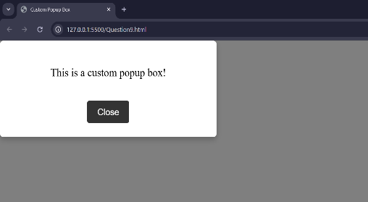OUTPUT 1:- OUTPUT 2:-

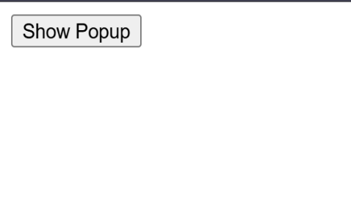

10. Create a sign-up form with the following requirements:

Users should be able to see hover states for all interactive elements on the page.

An error message should be displayed when the form is submitted if:

Any input field is empty. The email address is not formatted correctly.

HTML CODE :-

<!DOCTYPE html>

<head>

    <title> Deepteshrout Assignment 3 Question 10 </title>

    <script src=" https://ajax.googleapis.com/ajax/libs/jquery/3.3.1/jquery.min.js "></script>

    <style>

        body {

            font-family: Arial, sans-serif;

            display: flex;

            justify-content: center;

            align-items: center;

            height: 100vh;

            margin: 0;

            background-color: #f4f4f4;

        }

        #signup-form {

            background: #fff;

            padding: 20px;

            width: 300px;

            border-radius: 5px;

            box-shadow: 0 4px 8px rgba(0, 0, 0, 0.1);

        }

        #signup-form h2 {

            margin-top: 0;

            font-size: 24px;

        }

        .form-field {

            margin-bottom: 15px;

        }

        label {

            display: block;

            margin-bottom: 5px;

            font-weight: bold;

        }

        input[type="text"], input[type="email"], input[type="password"] {

            width: 100%;

            padding: 8px;

            border: 1px solid #ccc;

            border-radius: 3px;

            font-size: 14px;

        }

        input[type="text"]:hover, input[type="email"]:hover, input[type="password"]:hover {

            border-color: #555;

        }

        #submit-btn {

            width: 100%;

            padding: 10px;

            background-color: #4CAF50;

            color: white;

            border: none;

            border-radius: 3px;

            cursor: pointer;

            font-size: 16px;

            transition: background-color 0.3s ease;

        }

        /* Hover effect for button */

        #submit-btn:hover {

            background-color: #45a049;

        }

        .error-message {

            color: red;

            font-size: 14px;

            display: none;

            margin-bottom: 10px;

        }

    </style>

</head>

<body>

    <form id="signup-form">

        <h2>Sign Up</h2>

        <div class="error-message" id="error-message">Please fill in all fields correctly.</div>

        <div class="form-field">

            <label for="name">Name</label>

            <input type="text" id="name" placeholder="Enter your name">

        </div>

        <div class="form-field">

            <label for="email">Email</label>

            <input type="email" id="email" placeholder="Enter your email">

        </div>

        <div class="form-field">

            <label for="password">Password</label>

            <input type="password" id="password" placeholder="Enter your password">

        </div>

        <button type="button" id="submit-btn">Sign Up</button>

    </form>

    <script>

        $(document).ready(function() {

            $('#submit-btn').click(function() {

                $('#error-message').hide();

                var name = $('#name').val();

                var email = $('#email').val();

                var password = $('#password').val();

                if (name === "" || email === "" || password === "") {

                    $('#error-message').text("Please fill in all fields.").show();

                } else if (!validateEmail(email)) {

                    $('#error-message').text("Please enter a valid email address.").show();

                } else {

                    alert("Form submitted successfully!");

                    $('#signup-form')[0].reset();  // Optional: Reset form after submission

                }

            });

            function validateEmail(email) {

                var emailPattern = /^[^\s@]+@[^\s@]+\.[^\s@]+$/;

                return emailPattern.test(email);

            }

        });

    </script>

</body>

</html>

